Exercise 1.1

Created the Repository ‘Wireframes’
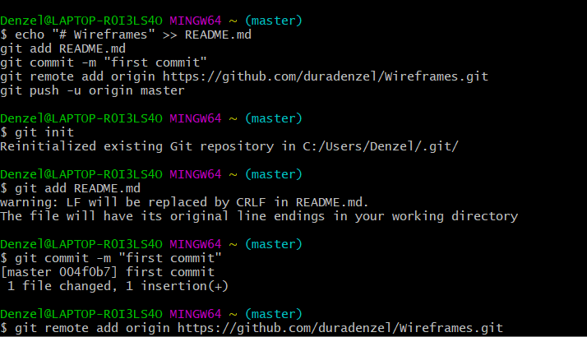

Exercise 1.2

Added the local repository

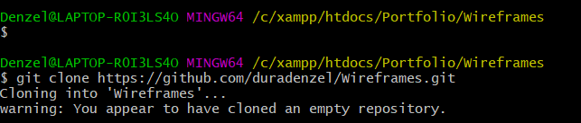

Exercise 1.3

Pushed the file containing the wireframes from local to remote location

